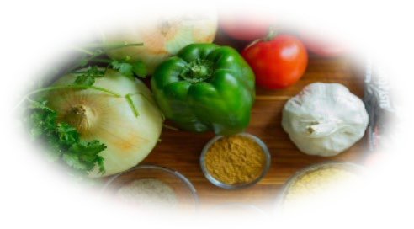
MEAL PLAN OF THE WEEK

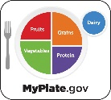
Foods or Ingredients I Already Have to Use This Week |  |  | Breakfast | Lunch | Dinner
 |  | Mon.
 |  | Tues.
 |  | Wed.
 |  | Thur.
Snack Ideas |  | Fri.
 |  | Sat.
 |  | Sun.

Did you remember to add a fruit and/or vegetable?
Aim to include at least ½ - 1 cup of vegetables with most meals and snacks every day
Aim to include at least ½ cup of fruit with most meals and snacks every day

Meal Planning with Confidence

Colorado State University, U.S Department of Agriculture and Colorado counties cooperating. Colorado State University Extension programs are available to all without discrimination. To simplify technical terminology, trade names or products and equipment occasionally will be used. No endorsement of product names is intended nor is criticism implied of products not mentioned.

General grocery (broth, canned goods, dried goods, nuts, etc.)
Produce (vegetables, fruits, herbs)
Fresh poultry, meat, and fish
Eggs and dairy
Frozen items
Bakery Items
Oil, vinegar, condiments, spices, baking items
Non-food items (cleaning supplies, personal care)
Others (pet food, etc.)
GROCERY LIST

